**Task 4: The Journey of Food Report (Chicken Breast)**

**By Nicole Whittle**

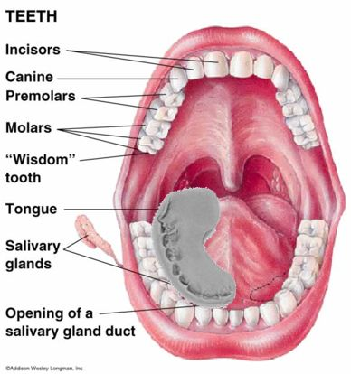**Mouth and Oesophagus:**

Firstly, the chicken enters the oral cavity where the teeth and salivary glands are located. The teeth mainly used when pulling apart protein, are the canines and molars. These 2 types of teeth focus on tearing and crushing the food into smaller, digestible parts. This is a display of mechanical digestion, the physical movement which assists with the breakdown of substances.

Chemical digestion also occurs during the process, due to the salivary glands. These glands begin secreting saliva, which is made up of digestive enzymes, water, and other chemical components. Specifically, the Parotoid glands release Amylase, a protein which helps break down starch and complex carbohydrates.

Diagram displaying oral cavity (Papers, I. 2013, June 22)

The mastication of chicken is repeated until it’s formed into bolus, a small round mass composed of food and saliva. It then travels through the pharynx and the epiglottis, a flap of cartilage which prevents food from entering the lungs. Then the bolus enters the oesophagus, a muscular tube which runs from the mouth into the stomach. Peristalsis, the contraction and relaxation of the muscles found in the oesophagus, form waves which assist with moving the bolus down the tube.

**Stomach**

For the chicken breast to be digested thoroughly, it relies mostly on the mechanical and chemical processes which occur in the stomach. Mechanical digestion occurs in the stomach via vigorous peristaltic contractions of the smooth muscles (Institute for Quality and Efficiency in Health Care, 2016). This promotes a movement known as churning. As a result of the churning, the bolus turns into chyme, a mixture consisting of gastric juices and partially digested chicken. This process usually takes around 2-4 hours before the chyme can be passed through to the small intestines (VidaFuel, 2022).

Additionally, glands found in the stomach lining help produce the gastric acid which is made up of hydrochloric acid and digestive enzymes. This gastric acid assists with the chemical breakdown of protein found in chicken. Specifically, stomach enzymes such as Pepsin serve to break down protein into smaller peptides and amino acids.

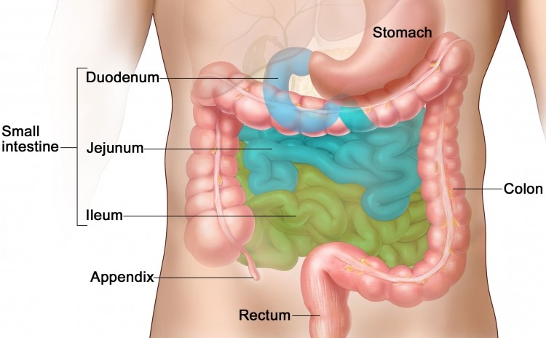

**Small Intestines**

Breakdown

The role of the small intestine is to help further break down the partially digested food in the chyme. This is also where the body absorbs the necessary nutrients, while also removing any unnecessary components (Collins, 2022). The cells which

Diagram of the small and large intestines. (Cutcliffe, 2018)

line the small intestines secrete additional enzymes, which finally break down the small segments of protein into individual chains of amino acids. However, most of the chemical breakdown is done by the pancreas, which produce a liquid known as pancreatic juice. Pancreatic juice contains a large amount of pancreatic (digestive) enzymes that are only activated when they enter the duodenum, the first part of the small intestines (Department of Health & Human Services, n.d).

Due to chicken breast also containing a small amount of fat, the liver and gall bladder are also involved in the process of digestion. The liver produces a liquid known as bile, which is stored and released from the gall bladder (Bile, n.d). The primary purpose of bile is to aid with fat digestion. This liquid breaks down fat into fatty acids, increasing their surface area making it easier for enzymes to act on (Villines, 2021).

Absorption

The small intestines are the site where nutrient absorption occurs. The inner lining of the small intestines, the mucous, is covered in microscopic finger-like 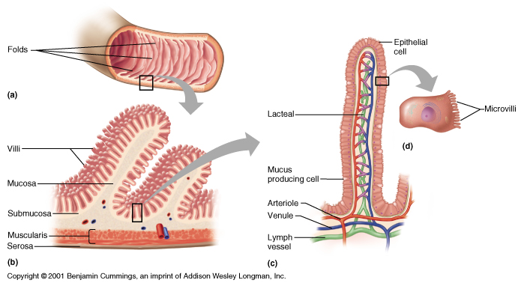pieces of tissue called villi, which also project into microvilli (Libretexts, 2023). Both structures are responsible for increasing the surface area, which enhances nutrient absorption. Furthermore, microvilli are also responsible for secretion of nutrients into nearby capillaries (Lakna, 2020). They are also covered in digestive enzymes, hence enhancing nutrient absorption/breakdown. Each villus contains a lacteal which is surrounded by nearby blood vessels (Toppr, 2022). In reference to protein (chicken breast), the broken-down fatty acids and glycerol from the low amount of fat found in chicken would be absorbed by the lacteal part of the villi. Meanwhile, the amino acids would be absorbed by the network of capillaries by the process of diffusion transportation (Vedantu, n.d).

Diagram of microvilli located in the small intestines (Socratic, n.d)

**Material Breakdown and Use**

Chicken is a high source of protein, however it does contain small amounts of fats which can also be absorbed by the body for use. Through digestion, protein is first broken down into peptides, by the pepsin enzymes located in the stomach. Lastly, the peptides are broken into individual chains of amino acids, by proteases secreted by the pancreas (Bsn, 2019). This allows the small intestines to easily absorb the amino acids into the bloodstream. The body uses proteins for a number of factors such as building and repairing muscles/bones, as well as the production of hormones and enzymes (Department of Health & Human Services, n.d).

Meanwhile, the fats are broken down into fatty acids, which can then be absorbed into the blood through the lacteal (Nemours KidsHealth, n.d). These fatty acids are then used to store energy, body insulation, and start chemical reactions which influence growth, immune function, metabolism, and reproduction (National Institute of General Medical Science, n.d). In cases where glucose isn’t available, the body can alternatively use stored fatty acids to conduct cellular activity.

**Large Intestine**

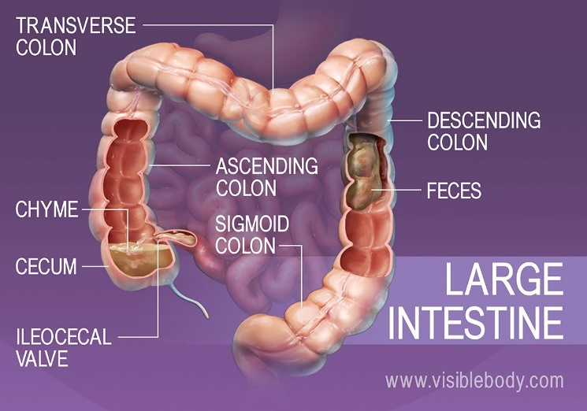By the time chyme reaches the large intestine, all the protein, fat absorption and digestion would have been completed. The main purpose of the large intestine is to absorb any water or salts which have not been digested as food (UPMC, 2020) It also turns the waste products from digestion into stool which can be excreted through the rectum with the use of peristalsis movements. The large intestines (colon) is also home to many types of bacteria, which are crucial for human health. Specifically, bacteria in the ascending part of the colon are experts in breaking down carbohydrates, because they produce large amounts of enzymes (Creative, 2016) Bacteria also helps neutralise harmful by-products, absorb nutrients, and produce vitamins such as Vitamin K, which is essential for blood clotting (Creative, 2016)

Diagram of the large intestines and process of elimination. (Body, n.d)

**Elimination and Faeces**

Defecation refers to the elimination of solid or semisolid materials (faeces) from the digestive tract. This process involves the contraction of the rectal muscles and relaxation of the internal anal sphincter, an involuntary smooth muscle located near the anus (Body, n.d). Faeces are made up of unabsorbed water, dead bacteria, undigested food, and bile pigments.

Bibliography

Papers, I. (2013, June 22). *HugeDomains.com*. Pinterest. <https://www.pinterest.co.kr/pin/353462270725232456/>

Cutcliffe, T. (2018, April 16). *Small intestine bacteria key in fat uptake, suggests mouse data*. <https://www.nutraingredients.com/Article/2018/04/16/Small-intestine-bacteria-key-in-fat-uptake-suggests-mouse-data>

*What is the purpose of the microvilli of the small intestine? | Socratic*. (n.d.). Socratic.org. <https://socratic.org/questions/what-is-the-purpose-of-the-microvilli-of-the-small-intestine>

Body, V. (n.d.-b). *Absorption and Elimination | Digestive Anatomy*. <https://www.visiblebody.com/learn/digestive/digestive-absorption-and-elimination>

Institute for Quality and Efficiency in Health Care (IQWiG). (2016, August 21). *How does the stomach work?* InformedHealth.org - NCBI Bookshelf. <https://www.ncbi.nlm.nih.gov/books/NBK279304/>

VidaFuel, T. (2022). Fast and Slow Proteins: The Difference and Role of Each. *Vida-Fuel*. <https://vidafuel.com/blogs/nutrition-wellness/fast-and-slow-proteins>

Collins, J. T. (2022, August 8). *Anatomy, Abdomen and Pelvis, Small Intestine*. StatPearls - NCBI Bookshelf. <https://www.ncbi.nlm.nih.gov/books/NBK459366/>

Department of Health & Human Services. (n.d.). *Pancreas*. Better Health Channel. <https://www.betterhealth.vic.gov.au/health/conditionsandtreatments/pancreas>

*Bile*. (n.d.). Mount Sinai Health System. <https://www.mountsinai.org/health-library/special-topic/bile>

Villines, Z. (2021, January 28). *How does the body digest fat?* <https://www.medicalnewstoday.com/articles/fat-digestion#fat-digestion>

Libretexts. (2023). 22.13A: Absorption in the Small Intestine. *Medicine LibreTexts*. <https://med.libretexts.org/Bookshelves/Anatomy_and_Physiology/Anatomy_and_Physiology_(Boundless)/22%3A_Digestive_System/22.13%3A_Absorption/22.13A%3A_Absorption_in_the_Small_Intestine>

Lakna. (2020). What is the Difference Between Villi and Microvilli. *Pediaa.Com*. <https://pediaa.com/what-is-the-difference-between-villi-and-microvilli/>).

Toppr. (2022). Explain the role of villi in absorption. *Toppr Ask*. <https://www.toppr.com/ask/question/explain-the-role-of-villi-in-absorption/>

*Amino acids are absorbed inA. Blood capillaries of villiB. Wall of the rectumC. Lacteals and blood capillaries of villiD. Lacteals of villi*. (n.d.). <https://www.vedantu.com/question-answer/amino-acids-are-absorbed-in-a-blood-capillaries-class-11-biology-cbse-5fc75a522b01962f7a42131e>

Bsn, M. D. R. (2018, February 23). *How Is Protein Digested?* Healthline. <https://www.healthline.com/health/protein-digestion#enzymes>

Department of Health & Human Services. (n.d.-b). *Protein*. Better Health Channel. <https://www.betterhealth.vic.gov.au/health/healthyliving/protein>

Fatty Acids (for Parents) - Nemours KidsHealth. (n.d.). Kidshealth.org. <https://kidshealth.org/en/parents/fatty-acids.html#:~:text=During%20digestion%2C%20the%20body%20breaks>

*National Institute of General Medical Sciences*. (n.d.). National Institute of General Medical Sciences (NIGMS). <https://www.nigms.nih.gov/education/Inside-Life-Science/Pages/what-do-fats-do-in-the-body.aspx#:~:text=Triglycerides%2C%20cholesterol%20and%20other%20essential,helping%20proteins%20do%20their%20jobs>

UPMC. (2020). Differences in Small & Large Intestines | Children’s Pittsburgh. Children’s Hospital of Pittsburgh. <https://www.chp.edu/our-services/transplant/intestine/education/about-small-large-intestines#:~:text=The%20purpose%20of%20the%20large>

Creative, K. (2016, August 11). *Bacteria and the large intestine - Love Your Gut*. Love Your Gut. <https://loveyourgut.com/all-entries/bacteria-and-the-large-intestine/>

Body, V. (n.d.). *Absorption and Elimination | Digestive Anatomy*. <https://www.visiblebody.com/learn/digestive/digestive-absorption-and-elimination#:~:text=Defecation%20Eliminates%20Waste%20From%20the,of%20the%20external%20anal%20sphincter>